Mirza Daniyal Baig L1F26BSCS0315

Task 07– Weather App (Draw the Flowchart, then Code)
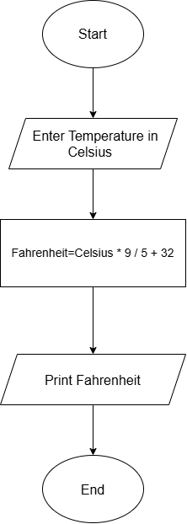

Task 8– Cinema Ticket (Reading a Flowchart with a Decision)
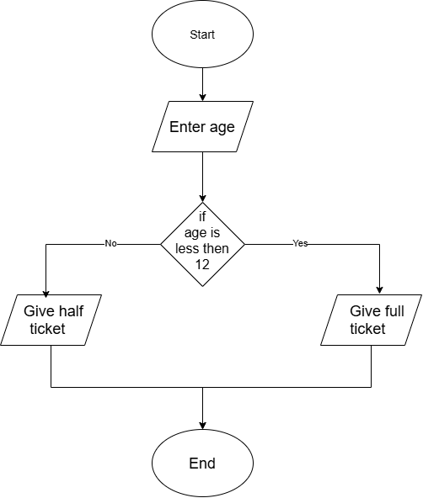
No. | Age | Condition (Age<12) | Ticket Printed
1 | 8 | Yes | Half
2 | 10 | Yes | Half
3 | 20 | No | Full
4 | 15 | No | Full
5 | 11 | Yes | Half

Task 03– Expression Quiz (Precedence and Associativity)

No. | Expression | Your Prediction | Actual Output
1 | 10 + 5 * 2 | 20 | 20
2 | (10 + 5) * 2 | 30 | 30
3 | 20 - 5 - 3 | 12 | 12
4 | 100 / 7 | 14 | 14
5 | 100 % 7 | 2 | 2
6 | 2 * 3+8/4-1 | 7 | 8

